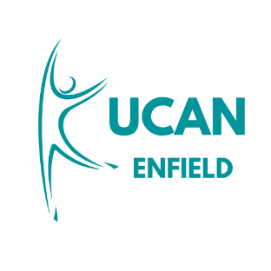
UCAN Enfield – the Unified Community Assistance Network is an exciting new collaborative, community-led initiative designed to enable Enfield residents to lead healthier, independent lives The programme Supporting Independence through Inclusion and Early Intervention will be delivered by a partnership of charities led by Age UK Enfield, with Mind in Enfield and Barnet, One to One, Middlesex Association for the Blind, Wellbeing Connect, Bread and Butter and Cooking Champions. All bringing their wealth of specialisms, experience and knowledge.
Criteria:
UCAN Enfield is a new health and wellbeing programme for Enfield residents aged 18+ who may be, individuals with neurodiversity, sensory impairments/loss, mental health concerns, loneliness older adults and people with long-term health conditions or at risk of developing them in the future.

Clients Details
Full Name: |  | Title:
Address: |  | Email address:
Telephone number: |  | Mobile number:
Date of Birth |  | Ethnicity:
Gender: |  | Religion:
Lives alone: | Yes ☐ No ☐ | Nationality:

Next of Kin Details
Name: |  | Relationship to client:
Address: |  | Telephone number:
Email address: |  | Do they have LPA? | Yes ☐ No ☐

GP Details
GP practice: |  | GP name:
Address: |  | Telephone number:
Email address:

Reasons for referral
Adult Autism Hub Activities | ☐
Eat healthier/ cookery workshops/talks | ☐
Exercise programmes including Falls | ☐
Support for your wellbeing | ☐
Leisure activities | ☐
Help to self-manage long term health conditions | ☐
Help to self-manage mental health concerns | ☐
Help to self- manage sensory loss and impairment | ☐
Ways to reduce social isolation and loneliness | ☐
Volunteering | ☐
Reasons for the referral:
Please include the following:
- Relevant medical history (please attach GP summary and prescription list if available)
- Any referral made to other services.
- Mobility information- is the person able to attend an office appointment?
- Any package of care/ other support in place- if so what type? E.g. family, neighbour, private arrangement, local authority funded?
- Any involvement from other services e.g. District nursing, Palliative care, Respiratory service.
- Does the person have any communication needs e.g. interpreter/ hard of hearing/ visual impairment.
- Any other relevant information

*Please note this list is not exhaustive*

Client Consent (MUST BE COMPLETED)
Has this referral been discussed and agreed with the client?  If you have requested we contact NOK, has this been discussed and agreed with the client? | Yes ☐ No ☐  (if this is not ticked, the person cannot be contacted for services)  Yes ☐ No ☐

Referrer’s Details
Referrer’s name: |  | Referrer’s organisation:
Referrer’s telephone number: |  | Referrer’s email address:

