Community BAME Advocacy Service

Summary: Mind in Enfield and Barnet (MiEB) is a leading VCS mental health provider that provides specialist mental health services to the residents of Barnet, Enfield and surrounding areas. MiEB is contracted, (via NCL CCG), to provide a number of services in Enfield via a Lead Provider model which see it achieve outcomes via direct provision and also sub-contracting arrangements with smaller VCS organisations to achieve a diverse range of outcomes.
Aim of service & key details:
In order to address health inequalities faced by the BAME community MiEB is procuring a specialist BAME Community advocacy service with the specific remit of empowering and supporting the mental health of the BAME Community in Enfield. The full detail of the service including it’s outputs and outcomes can be found in appendix one. Key headlines include:
Contract value: £18,758.00
Contract length: Until March 2023
Activity: The provision of community advocacy services to Enfield BAME residents with mental health issues.
Process:
- Invitation to quote advertised: 26/8/21
- Deadline for applications: 9/9/21
- Decision made: 10/9/21
- Award to subcontractor: 13/9/21
- Service Mobilisation: 20/9/21
If you are interested in working with us to provide this service please answer the application questions below in line with the service specification.

MiEB BAME Community Advocacy Quote Application

Technical Questions:

Area | Question | Information | Pass/Fail
Governance:  You must be a registered Charity, a CIC or CIO | Please let us know your status and the relevant registration number
Finance | Please send us your last set of publicly available accounts
References | Please provide us with contact details of two references that you have held contracts/sub-contracts with for the delivery of similar services.
Performance | Has your organisation had to (in the last 5 years) return/end a contract due to failure to deliver
Integrity | Has your organisation been found to have breached the equalities act or been deemed in an employment tribunal to have discriminated against an employee?

Question scoring system:
 | Definition
0 | Unacceptable – no evidence provided
1 | Poor – evidence provides little confidence and is below expectations
2 | Satisfactory and meets expectations
3 | Good – evidence provides full confidence standard will be met with full description and evidence of implementation
4 | Exceptional – evidence provides full confidence with relevant added value and additional services with full description and evidence of implementation and monitoring

Service Delivery
Question 2- Stakeholder Engagement: Please tell us how you will engage with different stakeholders to ensure service reach and impact, and community and client empowerment (word limit 500 )
Question 1 – Service Model: With reference to the service specification (appendix 1) please tell us how you will structure and deliver the service and reach the outcomes specified. Please include details of referral pathways, case triage and management, staff structure, and how different components of the service will work together [Word Limit 600]
Question 3 – Mobilisation: Please tell us how you would mobilise the service and give us an idea of what the first 90 days would look like. Within this please show us what potential risks there are and how you might overcome them. [Word limit 400]
Question 4 – Monitoring and data capture Please tell us how you will record, store and utlise relevant client information in order to provide quarterly monitoring and evidence impact. In addition to this please tell us if there are any additional things we can take into account when measuring client impact. [word limit 300]

Question 5 – The following policies are relevant to the mbilisation and delivery of this service. Please tell us if you have these policies and how they are relevant to the mobilisation and delivery of this service. If you do not have these policies please say how you will go constructing/developing them. Policies: ‘GDPR’, ‘Safeguarding’, ‘Equality, Diversity and Inclusion’, Recruitment policy, Finance policy, Complaints, Health and Safety. [300 words]

Please send your response back to leadership@mindeb.org.uk
Documentation/Info check:
- Completed Questionnaire
- Most recent set of accounts
- Safeguarding, GDPR and recruitment policies
- Two references

Appendix 1

- Sub-Contract Service Specifications

Service Specification No.
Services | Black and Ethnic Minority (BAME) Advocacy
Provider Lead | Mind in Enfield & Barnet
Sub-Contractor Lead
Period | _________ – 31st March 2023
Date of Review

1. Population Needs
  - National and local context
In England and Wales, about 1 in 5 people come from a Black, and minority ethnic (BAME) background. The mental health of BAME communities is important because people from these communities often face individual and societal challenges that can affect access to healthcare and overall mental and physical health.
In 2018 according to Diversity UK, about 13.8% of the UK population was from a minority ethnic background with London having 40% of its population from a Black and minority ethnic (BAME) background.
COVID-19 has brought health inequalities to the forefront more than ever before. However, for many the reality is that these inequalities and disparities are not a new phenomenon. COVID-19 has affected members of the BAME communities at a shockingly disproportionate level. Public Health England's report Beyond the data: Understanding the impact of COVID-19 on BAME groups highlighted the rate of infection and mortality as being much higher for those from particular BAME communities than for their non-BAME counterparts.
A survey of over 14,000 adults by Mind published in June 2020 has revealed that existing inequalities in housing, employment, finances, and other issues have had a greater impact on the mental health of people from BAME groups than white people during the coronavirus pandemic.
The online survey of over 25s in England and Wales found:
- Almost 1 in 3 BAME people said problems with housing made their mental health worse during the pandemic, compared to almost 1 in 4 white people.
- Employment worries have negatively affected the mental health of 61 per cent of BAME people, compared to 51 per cent of white people
- Concerns about finances worsened the mental health of 52 per cent of people who identified as BAME, compared to 45 per cent of those who identified as white.
- Other issues saw a similar pattern, including getting support for a physical health problem (39 per cent vs 29 per cent) and being a carer (30 per cent vs 23 per cent).

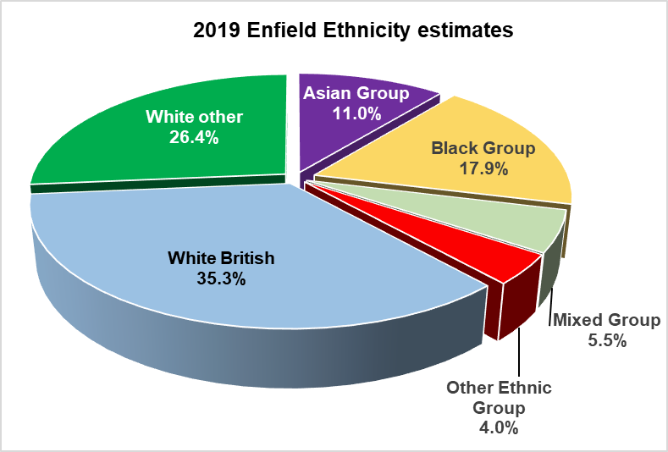
Enfield has a large, diverse population and has areas of high deprivation. 65% of residents are estimated to be from ethnic groups other than White British. Overseas-born residents make up 39% of the borough’s population. The top five non-English languages spoken by Enfield school pupils are Turkish, Somali, Polish, Albanian/Shqip and Bengali.

Source: Enfield Knowledge & Insight Hub

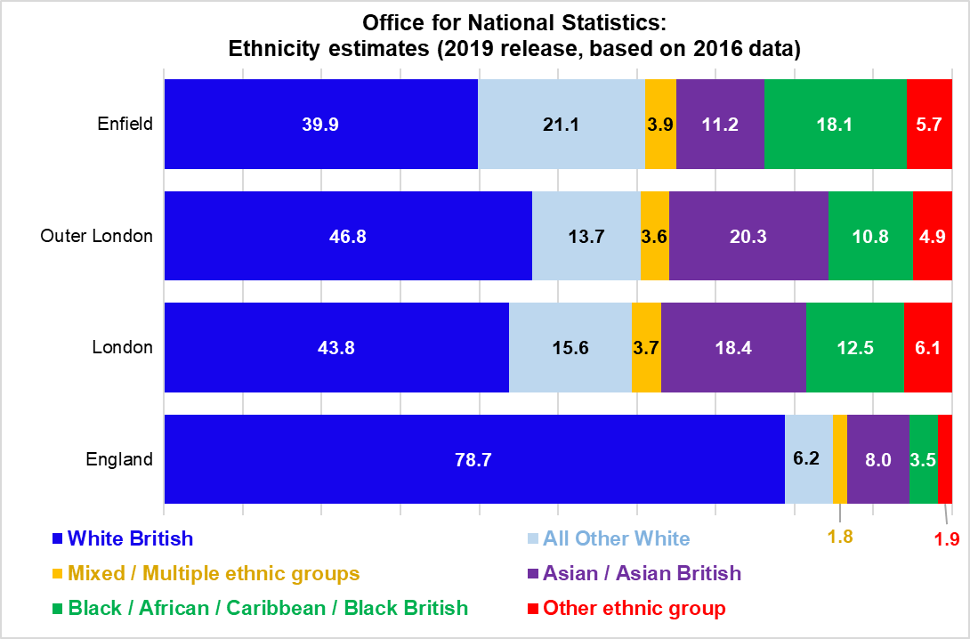
The Office for National Statistics (ONS) published estimates (higher than Enfield) in 2019 of the distribution of the ‘main’ ethnic groups used in statistical releases. The table below shows the ONS estimate of ethnicities in Enfield, with regional and national comparators.

Evidence has shown that the mental health needs of the BME groups are often not met, and that services responses and approaches have not always been the most appropriate or relevant (Bhui ed 2002). Findings for mental health and mental health services indicate high levels of disadvantage and inequality for BME communities. The evidence shows that individuals from BAME communities are more likely to be subject to:

- over-diagnosis of schizophrenia and under-diagnosis of depression or affective disorder.
- compulsory admission under the Mental Health Act, 1983 (Mental Health Act Commission 1999)
- involvement of police in admission to hospital and the use of Section 136/137 of the Mental Health Act, 1983
- over-use of psychotropic medication
- admission to medium- and high-secure facilities
- excessive admissions to hospital, especially via the courts.
People from a BME background are less likely to be referred for psychotherapy, psychological treatments, counselling, or other complementary treatments.

Successive reviews have found that people from black and minority ethnic (BAME) communities, particularly young men, are over-represented in inpatient and secure settings and more likely to be admitted into mental health services via the criminal justice system.

The Mental Health Act is more likely to be used for people from BAME communities. Services were found to be culturally inappropriate. The Care Quality Commission has reported higher rates of usage of CTOs (Community treatment orders) for people from BME groups.

There is also evidence that primary care services need to play a bigger role and that greater use of community-led organisations can be effective. The literature describes a ‘cycle of fear’: people from BME groups are wary of the services, and services in turn are fearful of young black men, with staff lacking in confidence and knowledge in responding to their needs. It was also reported that all these issues were underpinned by underlying prejudice and discrimination.

2. Purpose
The purpose of this Service Specification is to outline the requirements for __________ (the chosen provider) via the Lead Provider for the Voluntary and Community Sector (VCS) in the delivery of Black and Minority Ethnic (BAME) Population Advocacy.

Enfield’s system providers, including the Voluntary and Community Sector (VCS) organisations, are a crucial part of the delivery of NHS England’s strategic ambitions in the Long Term Plan. A key part of the development of Integrated Care Systems and Primary Care Networks Enfield is maintaining a vibrant and diverse Voluntary and Community sector.

Via the Lead Provider model, ___________________ (the chosen provider) will:
- Provide an advocacy service for Ethnic Minority populations registered with a GP in Enfield.
- Provide one to one (time limited, according to client need) issue-based advocacy, delivered through a range of media (email, telephone, face to face) and settings as required to meet the needs of the population
- Undertake targeted promotion and provide culturally appropriate information on the advocacy service, and relevant issues and rights including Mental Health information and Legal Rights.
- Build service capacity and community resilience by developing Group Advocacy and peer advocacy networks
- Encourage the development of self-advocacy skills throughout all engagements to move towards independence.
- Ensure that all work is underpinned by the Advocacy Charter principles
- Work with the Lead Provider to identify additional community needs and develop strategies to meet these and improve organisational and community resilience.

3. Outcomes
The specific outputs expected are:

- 75 individual clients per annum for the first year, increasing to 80 per annum thereafter
- Numbers of new clients (those that have never accessed the service previously) reached will also be expected to increase on an annual basis (minimum 40% new client intake in year 2).
- Minimum 2 self-advocacy support groups/ training/ activity per annum.

Fenton K, Pawson E, de Souza-Thomas L. (2020) Beyond the data: Understanding the impact of COVID-19 on BAME groups. Public Health England. https://assets.publishing.service.gov.uk/government/uploads/system/uploads/attachment_data/file/892376/COVID_stakeholder_engagement_synthesis_beyond_the_data.pdf
Mind (2020) The mental health emergency: how has the coronavirus pandemic impacted our mental health? https://www.mind.org.uk/media-a/5929/the-mental-health-emergency_a4_final.pdf
Bhui, K. (Ed.). (2002). Racism and mental health: Prejudice and suffering. Jessica Kingsley Publishers.
Ethnicity: An Agenda for Mental Health Edited by D. Bhugra and V. Bahl. 1999. London: Gaskell. 262 pp.
Breaking the Circles of Fear: A review of the relationship between mental health services and African and Caribbean communities | The Sainsbury Centre for Mental Health 2002. https://www.centreformentalhealth.org.uk/sites/default/files/breaking_the_circles_of_fear.pdf
NIMHE (2003) Inside Outside – Improving Mental Health Services for Black and Minority Ethnic Communities in England, (Dept of Health) https://www.diversecymru.org.uk/wp-content/uploads/inside_outside.pdf
Mental Health Foundation Black and Minority Ethnic Communities http://www.mentalhealth.org.uk/help- information/mental-health-a-z/B/BME-communities/
MIND (2013) Mental health crisis care: commissioning excellence for BME group. http://www.mind.org.uk/media/494422/bme-commissioning-excellence-briefing.pdf
Monitoring the Mental Health Act in 2017/18 | Care Quality Commission (CQC) http://www.cqc.org.uk/sites/default/files/media/documents/cqc_mha_report_2011_main_final.pdf

