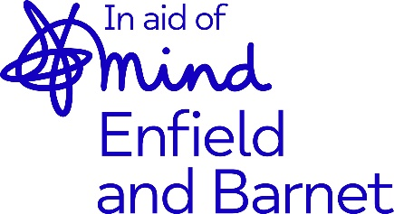

275 Fore Street
Edmonton
London
N9 0PD
T: 0208 887 1480
Gift Aid declaration
Please treat
The enclosed gift of £ ____________ as a Gift Aid donation; OR
All gifts of money that I make today and in the future as Gift Aid donations, OR
All gifts of money that I have made in the past 6 years and all future gifts of money that I make from the date of this declaration as Gift Aid donations.
Please tick the appropriate box
I understand that I must pay an amount of Income Tax and/or Capital Gains Tax in the tax year at least equal to the amount of tax that all the charities and CASCs I donate to will reclaim on my gifts for that tax year. I understand that other taxes such as VAT and Council Tax do not qualify. I understand that Mind in Enfield and Barnet will reclaim 25p of tax on every £1 that I have given.
Donor’s details
Title ___________ Initial(s) ____________ Surname __________________________________
Home address _________________________________________________________________
_____________________________________________________________________________
Postcode __________________________
Signature __________________________ Date ______________________________________
Please notify Mind in Enfield and Barnet if you:
- Want to cancel this declaration.
- Change your name or home address.
- No longer pay sufficient tax on your income and/or capital gains.
If you pay income tax at the higher rate, you must include all your Gift Aid donations on your Self-Assessment tax return if you want to receive the additional tax relief due to you.

